**Database Foundations for Business Analytics: Homework #2**

Q.1:

**ANSWER.** The first table violates the first normal form rule as multiple values are present in the Dependent column (Multiple dependents, their first and last names and also their relationship) and also Employee Name can be split as Employee First Name and Employee Last Name, all of this violates the need to maintain atomicity as a part of 1NF.

**ANSWER.** Once we apply the First Normal Form Rule, we will be splitting the columns EmployeeName into Employee First Name & Employee Last Name and also the Dependent Column into Dependent First Name, Dependent Last Name and Relationship. Doing this will help us to attain atomicity across the table.

The table after **applying the first normal form** the Employee Steven King has 2 dependents, we will have 2 separate rows for each dependent to maintain atomicity.

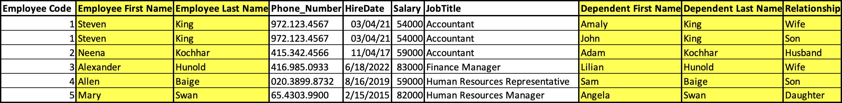

When we apply the second normal form, we will be creating the Employee Table, JobTitle Table, Dependent Table and Relationship Table to satisfy the “No Partial Dependency” rule which is a part of the second normal form.

Q.2:

1. **First Normal Form (1NF):**

**ANSWER.** After applying the first normal form we will be able to add the following columns – Employee First Name, Employee Last Name & split the Location address into Location Address and Zip Code.

Doing this will help us to attain atomicity across the table.



1. **Second Normal Form (2NF):**
   1. Department, Country, and Region are not dependent on each employee. Multiple employees can belong to these entities.
   2. Create new entities for department, Country, Region, and location

**ANSWER.**

To satisfy the second normal form, first we make sure the first normal form is satisfied and from Q1 we know that by adding columns for Employee Name and Location address we have maintained atomicity.

Now to ensure removal of partial dependency, we will create new entities which are not fully dependent on the primary key. Hence, we create Employee table which contains data directly in relation to the employee. Next, we create Jobtitle table which has data related to the Jobtitle and Department table with its respective Department Codes and the same is followed for the Country table and Region table. We create another entity for Location Address with its data split between Zip Code and the Location Address.

Now after creating all the entities, we can link the different entities to the main Employee table by mentioning the code of each table in the Employee table and once we do that we have achieved Second Normalization Form or 2NF.



